Experiment 2 – DSP Lab

Mohadeseh Azari, 810196404

- Part One
In this part we implement an IIR filter using fdatool in Matlab, the following is my IIR_Filter in Matlab:

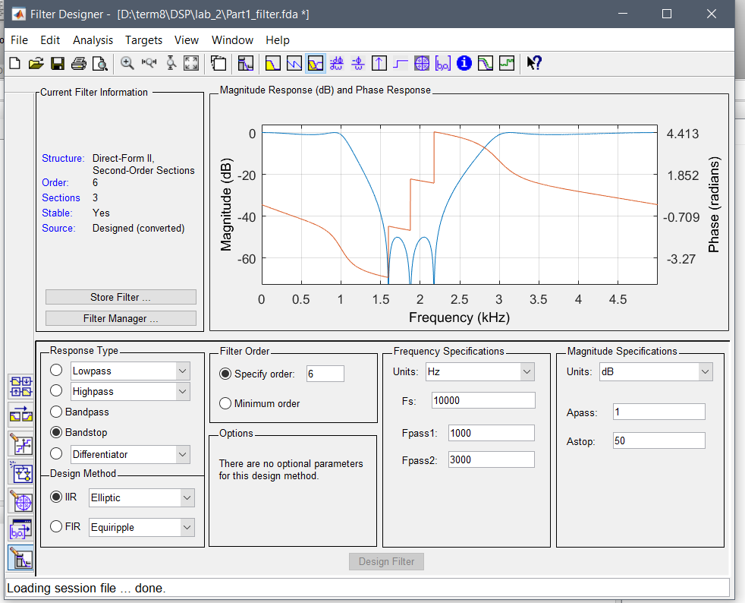
IIR_Filter

This IIR filter have the following properties:
- Fs = 10000Hz
- Fpass1 = 1000Hz
- Fpass2 = 3000Hz
- Apass = 1dB
- Astop = 50dB

The aim is to implement this filter using 3 serialized second degree filters.

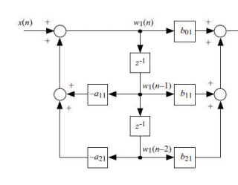

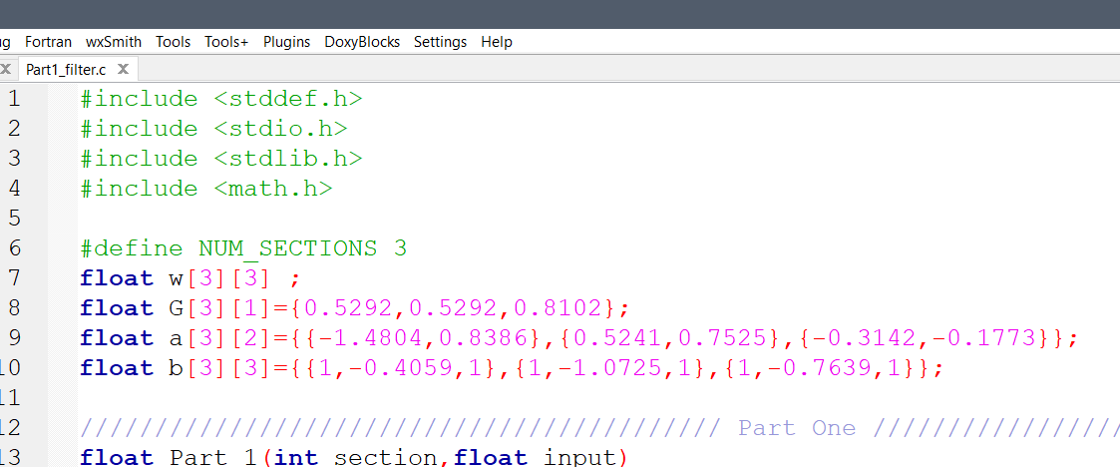

First part of the code concerns with coefficients like a&b and G as a gain.

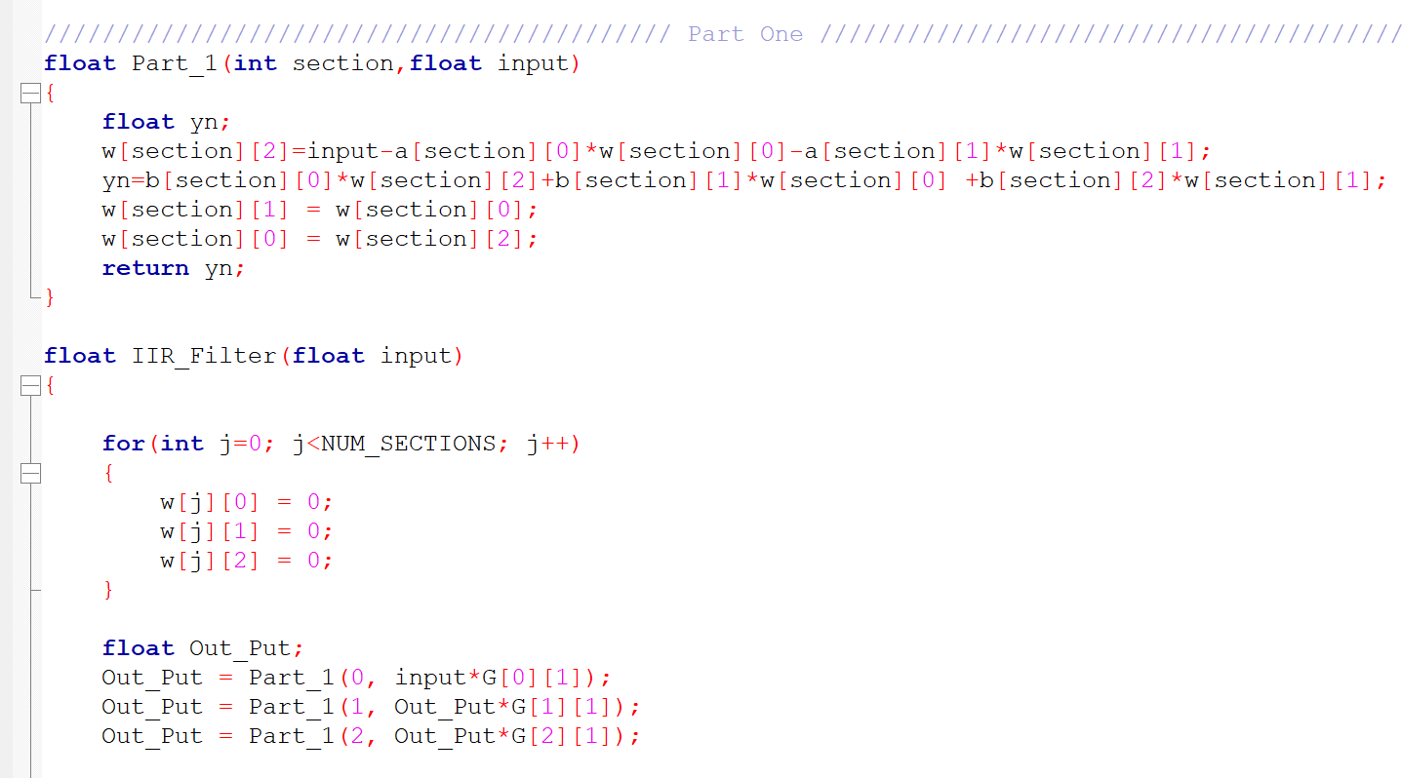

The second part of the code is our IIR filter like the code in manual description with the gain part which has been added.

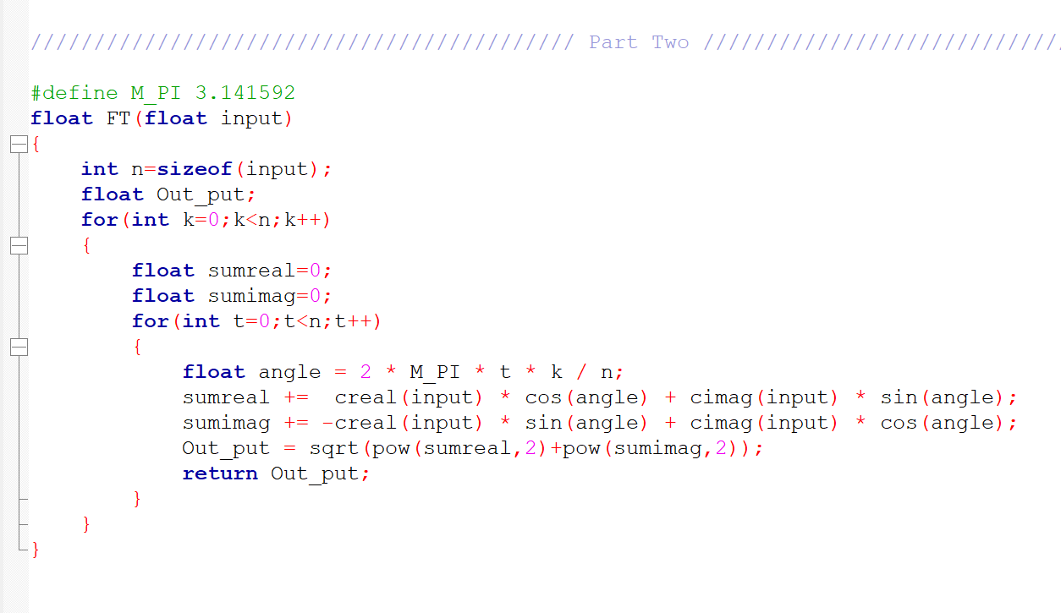

Part two takes the signal as an input and returns the DFT of the input signal as the discrete Fourier transform of the signal.

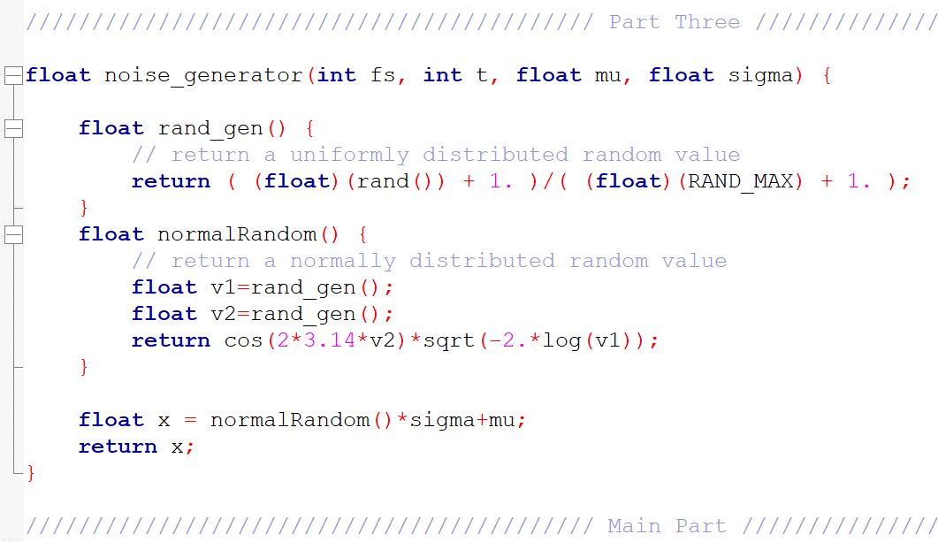

Unfortunately, I couldn’t plot my output file. All the files are in the code folder.

